**NAME- ROUSHAN; UID-23BCC70013; SUB- FULL STACK**

EXPERIMENT-03

* **AIM:** To design a responsive Admin Dashboard using CSS Grid Layout with dynamic theme switching functionality (light/dark mode) using JavaScript.
* **THEORY: CSS Grid** is a powerful layout system in CSS that allows developers to create two-dimensional layouts on the web (rows and columns).
* **Dynamic theme switching** enables a user to toggle between themes (e.g., light and dark) without reloading the page. This is achieved by manipulating CSS classes and variables using JavaScript.
* **CSS Variables** (--variable-name) are used for maintaining theme-specific values like background, text color, etc.
* By toggling between two classes (e.g., light-theme and dark- theme) on the <body> element, we can dynamically switch between themes.

# CODE:

## Index.html:

<!DOCTYPE html>

<html lang="en">

<head>

<meta charset="UTF-8" />

<meta name="viewport" content="width=device-width, initial- scale=1.0" />

<title>Admin Dashboard</title>

<link rel="stylesheet" href="style.css" />

</head>

<body class="light-theme">

<div class="dashboard">

<aside class="sidebar">

<h2>Admin</h2>

<nav>

<a href="#">Dashboard</a>

<a href="#">Users</a>

<a href="#">Settings</a>

<a href="#">Reports</a>

</nav>

</aside>

<header class="header">

<h1>Dashboard</h1>

<button id="themeToggle">Switch Theme</button>

</header>

<main class="main">

<div class="card">ç# ¡/ Sales Report</div>

<div class="card">+ User Statistics</div>

<div class="card">☼O◦ System Status</div>

<div class="card">´u, J◆ Inventory</div>

</main>

<footer class="footer">© 2025 Admin Dashboard</footer>

</div>

<script src="script.js"></script>

</body>

</html>

## style.css:

-- :root {

--bg-color: #ffffff;

--text-color: #000000;

--primary-color: #f0f0f0;

--accent-color: #007bff;

}

body.dark-theme {

--bg-color: #121212;

--text-color: #ffffff;

--primary-color: #1e1e1e;

--accent-color: #66b2ff;

}

body { margin: 0;

font-family: Arial, sans-serif; background-color: var(--bg-color); color: var(--text-color);

transition: all 0.3s ease;

}

.dashboard {

display: grid;

grid-template-areas: "sidebar header" "sidebar main" "sidebar footer";

grid-template-columns: 220px 1fr; grid-template-rows: 60px 1fr 40px; height: 100vh;

}

.sidebar {

grid-area: sidebar;

background: var(--primary-color); padding: 1rem;

}

.sidebar h2 { margin-top: 0;

}

.sidebar nav a { display: block;

color: var(--text-color); padding: 0.5rem 0;

text-decoration: none;

}

.sidebar nav a:hover { color: var(--accent-color);

}

.header {

grid-area: header;

background: var(--primary-color); display: flex;

align-items: center;

justify-content: space-between; padding: 0 1rem;

}

.header button { padding: 0.5rem 1rem;

background: var(--accent-color); color: #fff;

border: none; cursor: pointer;

}

.main {

grid-area: main; padding: 1rem; display: grid;

grid-template-columns: repeat(auto-fit, minmax(220px, 1fr));

gap: 1rem;

}

.card {

background: var(--primary-color); padding: 1rem;

border-radius: 8px;

box-shadow: 0 0 5px rgba(0,0,0,0.1);

}

.footer {

grid-area: footer;

background: var(--primary-color); text-align: center;

line-height: 40px;

}

1. **script.js**: -

const toggleBtn = document.getElementById('themeToggle'); const body = document.body;

toggleBtn.addEventListener('click', () => { body.classList.toggle('dark-theme'); body.classList.toggle('light-theme');

});

# OUTPUTS:

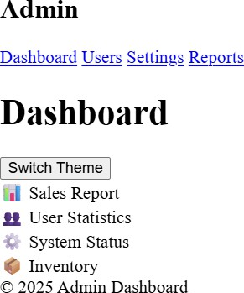



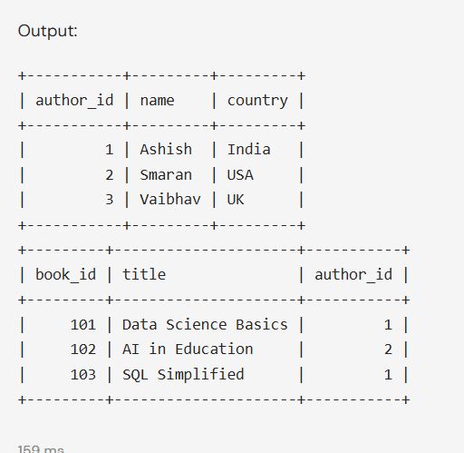

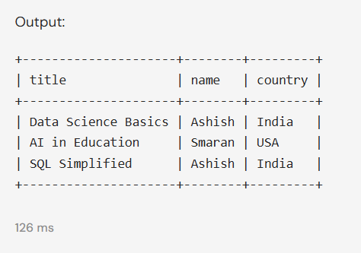

* + **LEARNING OUTCOMES:**
* Understood the concept of **CSS Grid Layout** for building responsive admin panels.
* Learned how to use **CSS Variables** for theme-based styling.
* Implemented **JavaScript-based theme switching** with DOM manipulation.
* Developed a **modular and scalable dashboard layout**.
* Gained practical experience in front-end development using

**HTML, CSS, and JavaScript**.